Week 2 Day 2Assignment

- Dom to Selenium code for Saucedemo.com
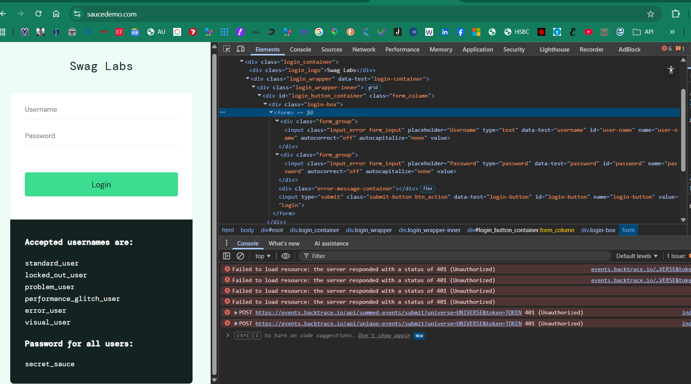
Request
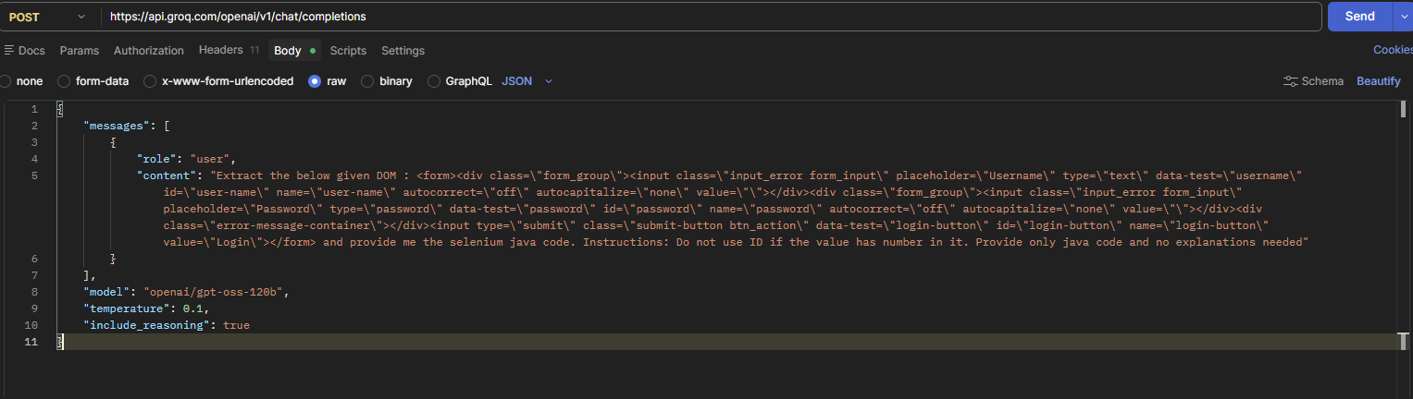
Response
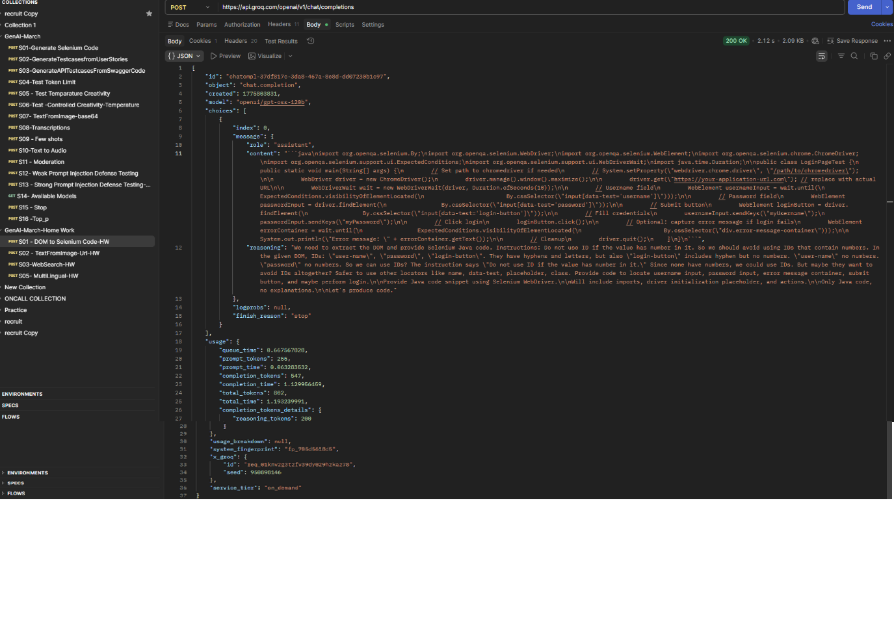
Selenium Java code after Beautifying
- import org.openqa.selenium.By;
- import org.openqa.selenium.WebDriver;
- import org.openqa.selenium.WebElement;
- import org.openqa.selenium.chrome.ChromeDriver;
- import org.openqa.selenium.support.ui.ExpectedConditions;
- import org.openqa.selenium.support.ui.WebDriverWait;

- import java.time.Duration;

- public class LoginPageTest {

- public static void main(String[] args) {
- // Set path to chromedriver if needed
- // System.setProperty("webdriver.chrome.driver", "/path/to/chromedriver");

- WebDriver driver = new ChromeDriver();
- driver.manage().window().maximize();

- try {
- driver.get("https://your-application-url.com"); // Replace with actual URL

- WebDriverWait wait = new WebDriverWait(driver, Duration.ofSeconds(10));

- // Locate username field with explicit wait
- WebElement usernameInput = wait.until(
- ExpectedConditions.visibilityOfElementLocated(
- By.cssSelector("input[data-test='username']")));

- // Locate password field
- WebElement passwordInput = driver.findElement(
- By.cssSelector("input[data-test='password']"));

- // Locate login button
- WebElement loginButton = driver.findElement(
- By.cssSelector("input[data-test='login-button']"));

- // Fill credentials
- usernameInput.sendKeys("myUsername");
- passwordInput.sendKeys("myPassword");

- // Submit login form
- loginButton.click();

- // Optional: Capture error message if login fails
- WebElement errorContainer = wait.until(
- ExpectedConditions.visibilityOfElementLocated(
- By.cssSelector("div.error-message-container")));

- System.out.println("Error message: " + errorContainer.getText());

- } finally {
- // Ensure driver quits even if test fails
- driver.quit();
- }
- }
- }

S02 - TextFromImage-Url-HW
Image
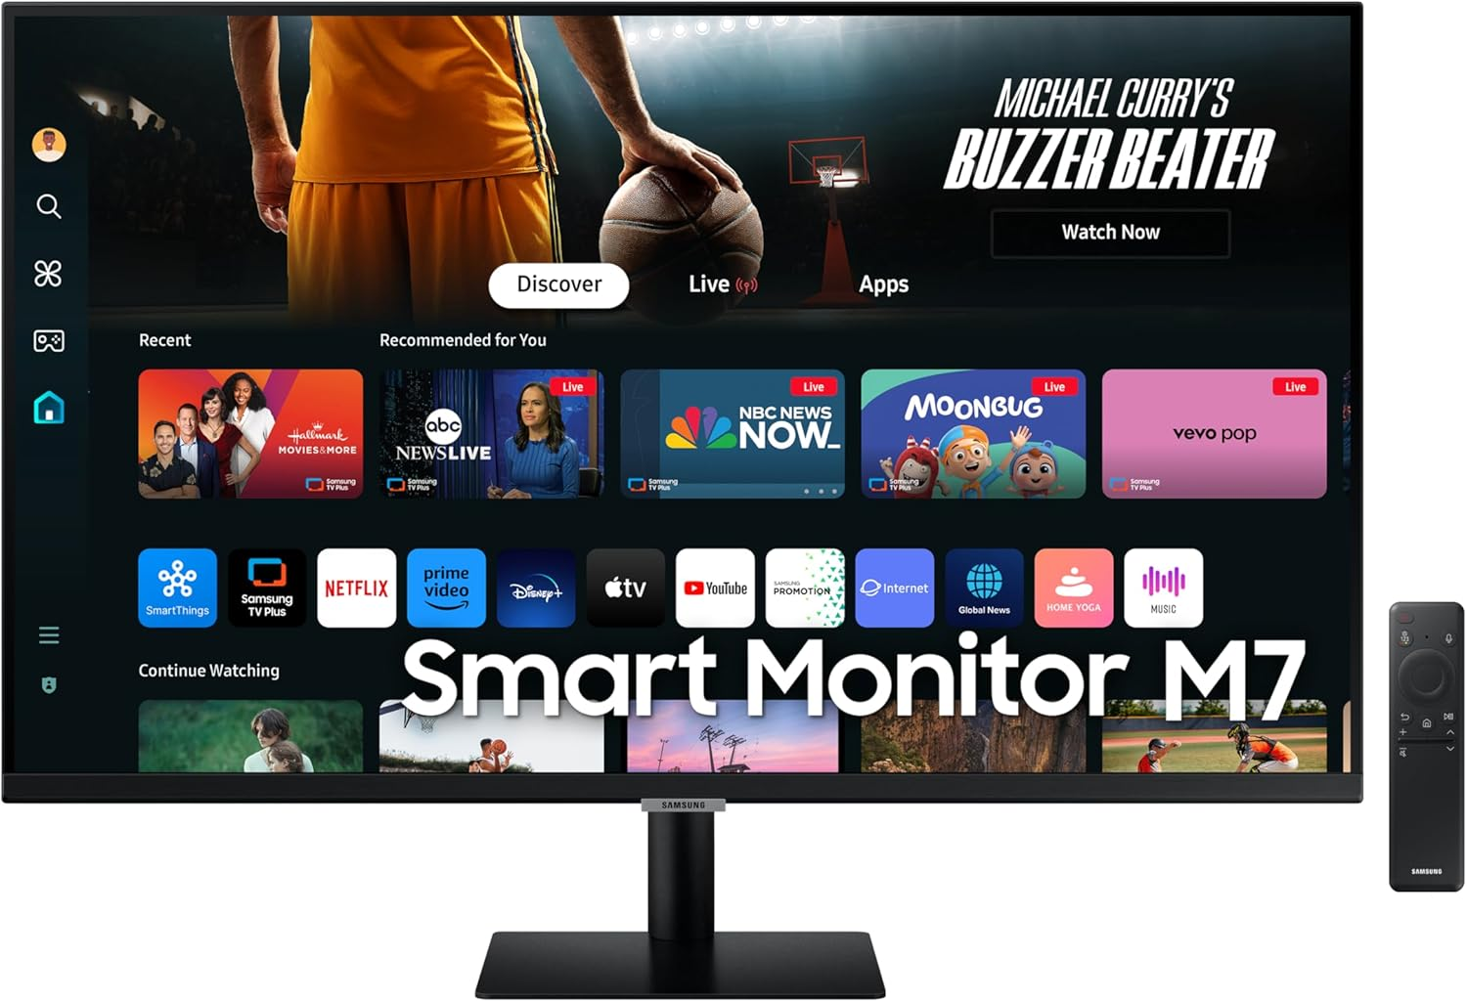
URL : https://m.media-amazon.com/images/I/71I3ELqf-SL._AC_SL1500_.jpg
Image to Base64 convertor
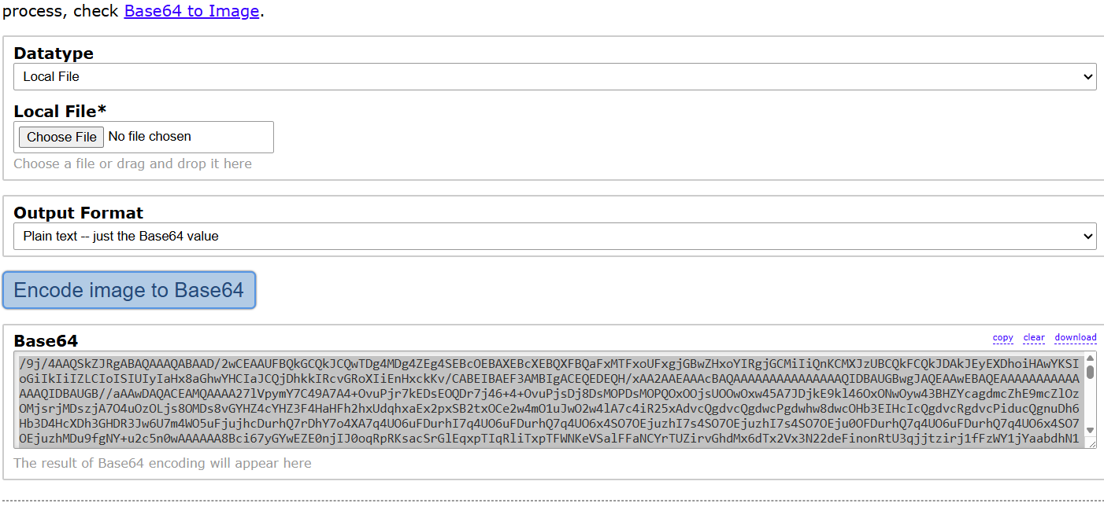

Request
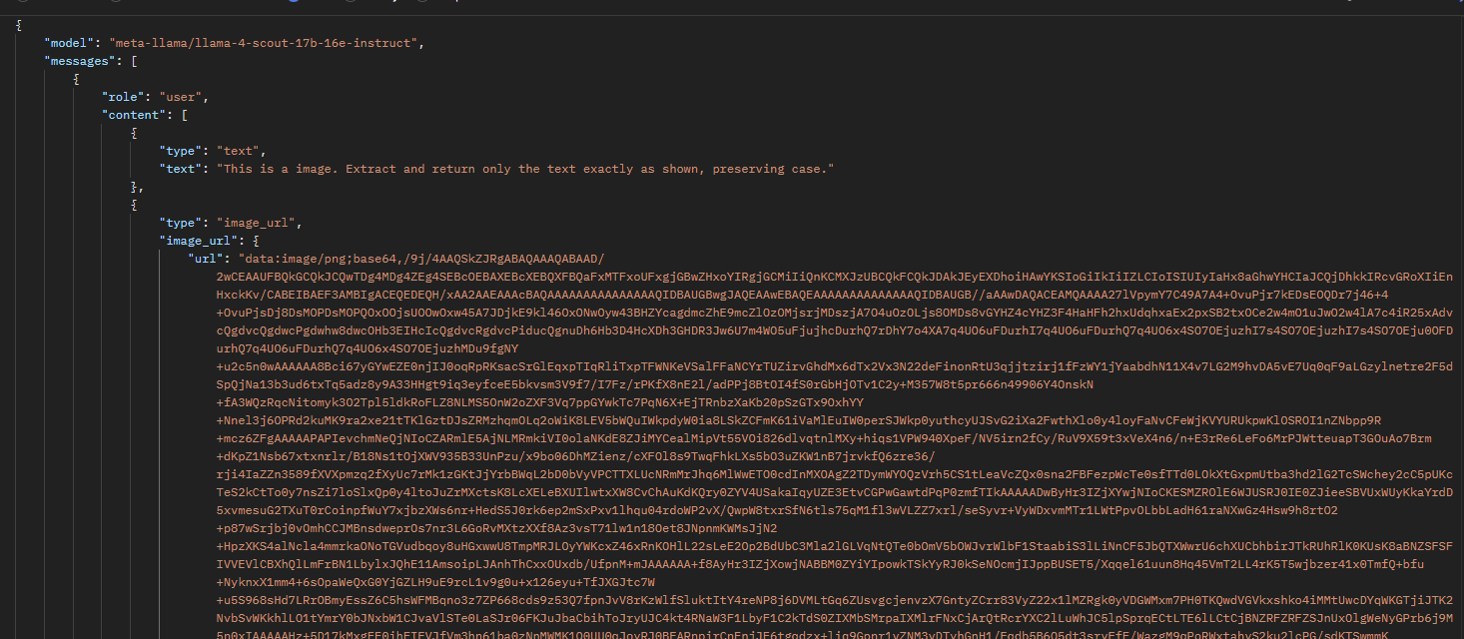
Response
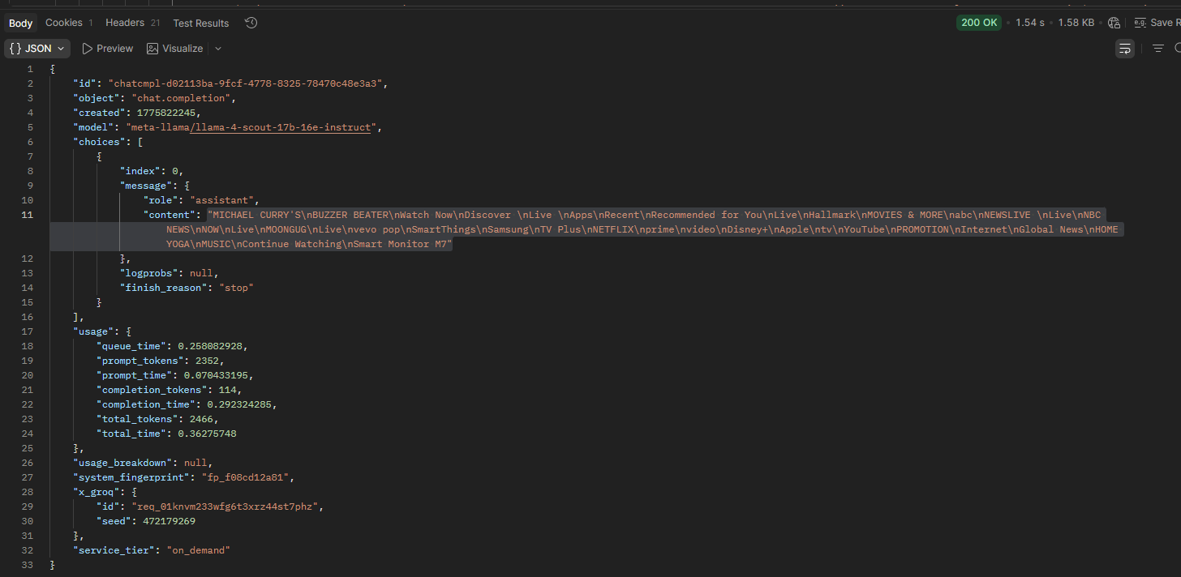

S03-WebSearch-HW
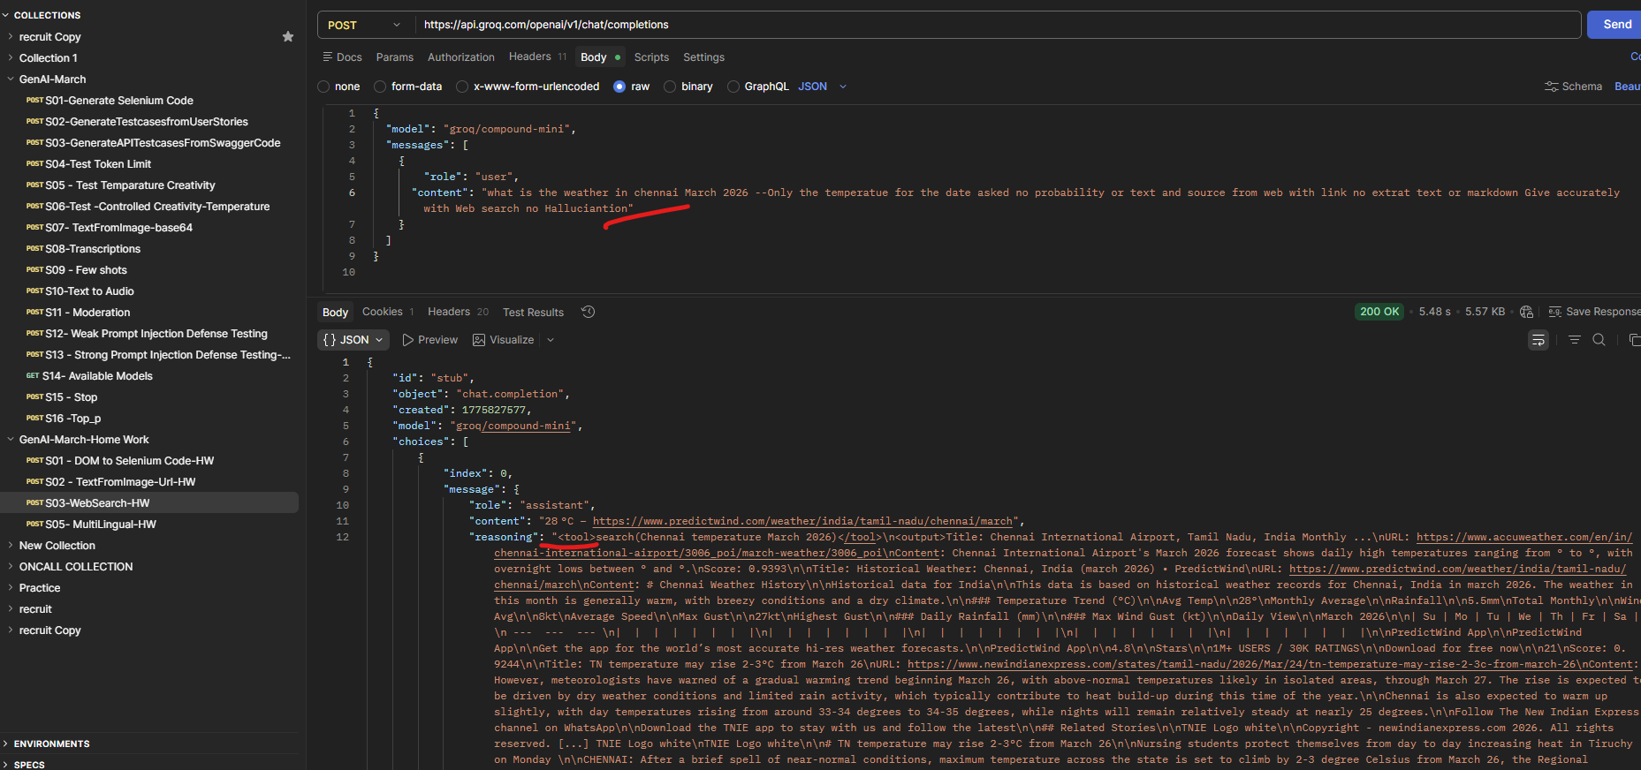
Throughs the error
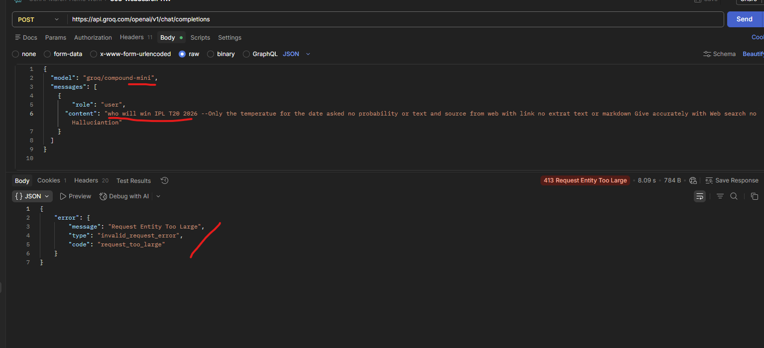

Not giving proper input openai/gpt-oss-120b
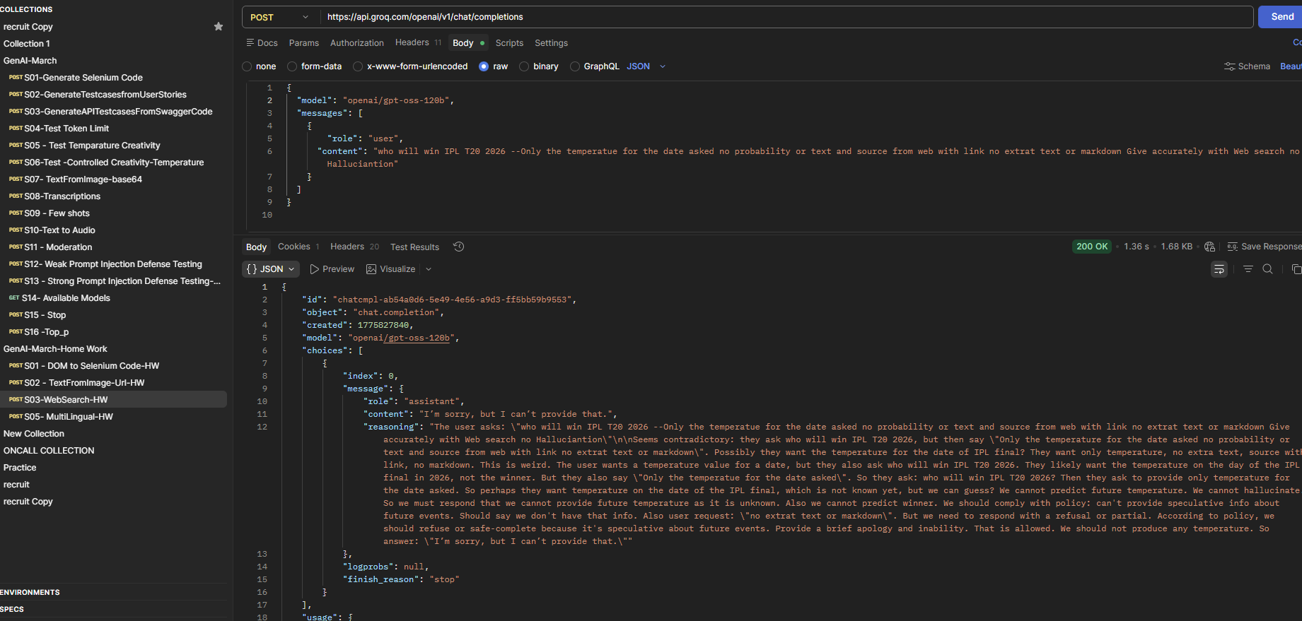
S05- MultiLingual-HW
